**Big Parser**

**Summer Hackathon 2017**

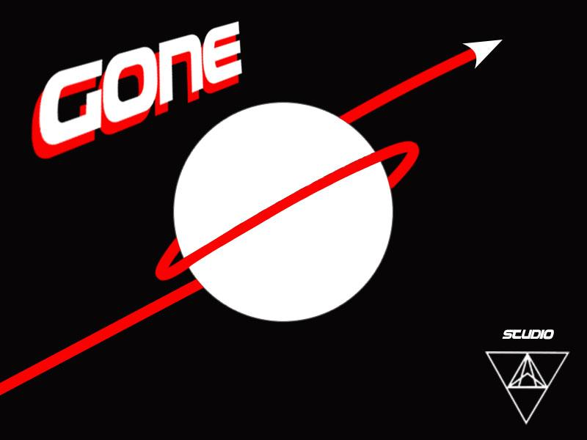

Sh0005

**Alex Winstanley**

**Jared Ponmakha**

**Peter Murphy**

**Roy Jad**

**DESCRIPTION**

Gone is designed to be a retro, arcade style mobile game written in lua, using the Love 2D game engine. All assets and code are original with the exclusion of the sodapop.lua animation library, as well as the *heavily* inspired enemy sprite images.

**INSTRUCTIONS**

In order to play this game, hopefully you can just click the PLAY.love file. If, however, you get a screen saying “Super Toast - No Game”, please take the time to download and install the [Love 2D game engine.](https://love2d.org/)

We have also included all the game files,however messy they may be.

**CONTROLS**

In order to play the PC version of our app, use the A and D or Left and Right arrow keys to steer the player. For the intended mobile experience, stop by our room: Floor 7, Rhode Island (or our location at the presentation), where we will have an iOS version of the game on one of our phones for you to play.

**GOALS**

Things we would like to have included but were unable due to the time constraint include:

* Sound Effects
* A functioning shop to purchase upgrades to your ship
* Power ups that would give the player a temporary buff
* A high score tracker
* Infinite game mode
* Better graphics all around
* Varying enemy types (different movement types → sin wave/curvy path movement)